Dimension Pattern and Hierarchy Practice Questions

1. A star schema at a hospital is modeled as follows. (Dimension attributes not shown).
The hospital administration wants you to enhance the data warehouse to include the following information to support reporting. How would you extend the schema to include the additional attributes?
Hospital Admission Type – walk-in, Ambulance, transfer from another hospital;
Level of care – ICU, Med Floor, Ped ICU, Surgery
Outcome: Cure, Worsening, Mortality
Transfer to another hospital: Yes/No
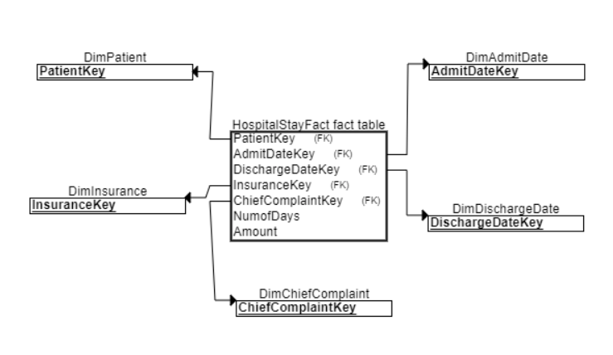

2. The positions in an organization attribute includes levels such as CEO, VP, Director, Manager, and three levels of independent contributors (IC1, IC2, IC3). Here are two sample reporting structures. How would you model the hierarchy in a data warehouse?
